PROMOCION ANTIICPADA NOVENO

REHEARSAL ACTIVITY

FIRST TERM

En su cuaderno desarrolle el taller, marque su trabajo con nombre y grado, tome las fotos y envíelo a susanarivero@iehoracio.edu.co o preséntelo en clase.

1.Escriba el siguiente taller con sus dibujos y desarróllelo. Busque un diccionario de inglés para hacerlo.

VOCABULARY

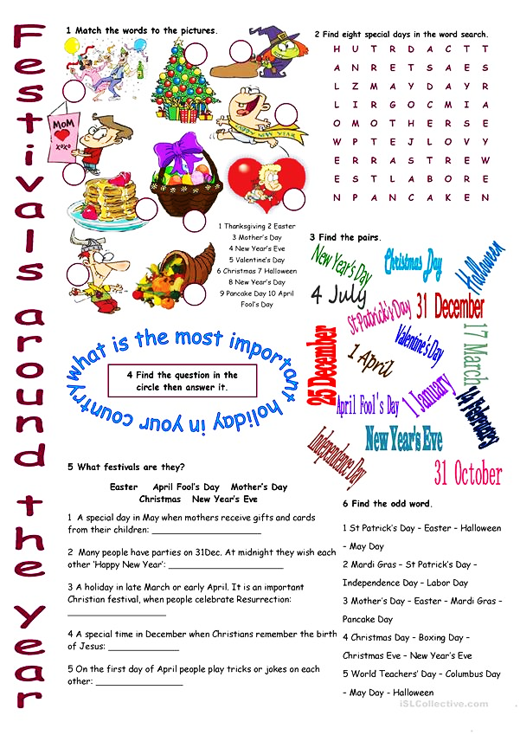

Reading Comprehension Activity

Interesting Festivals around the World
Festivals have been organized for thousands of years. A festival is an event celebrated by a particular community, or the entire country, and it is centered on some particular tradition.Most, but not all festivals serve to provide entertainment to the participants, so they tend to be complemented with music or dance. The majority of festivals are religious or based on folklore.
- What is a festival?
- What can you find in a festival?
- Give 5 examples of festivals in Colombia. Write the dates.
For example:

Festival Date

Christmas in Colombia the 24th of December 1st 21st 22nd 23rd 24th 25th

1.______________ ______________

Verbs

Present past meaning Regular/irregular

Write wrote escribir Irregular
Buy
Have
To be(was/were)
Call called llamar Regular
Like
Want
Fight
Help
Get married

En su cuaderno desarrolle el taller, marque su trabajo con nombre y grado, tome las fotos y envíelo a susanarivero@iehoracio.edu.co o preséntelo en clase.
REHEARSAL ACTIVITY
SECOND TERM

Activity 1: Con apoyo del diccionario, lea la siguiente información y conteste los puntos A y B.

TECHNOLOGY VOCABULARY
- Match the vocabulary to the pictures by writing the name of them.
Laptop -Wi-Fi -computer - touchscreen - game - text message - email - mouse – mobile - keyboard –webside - screen
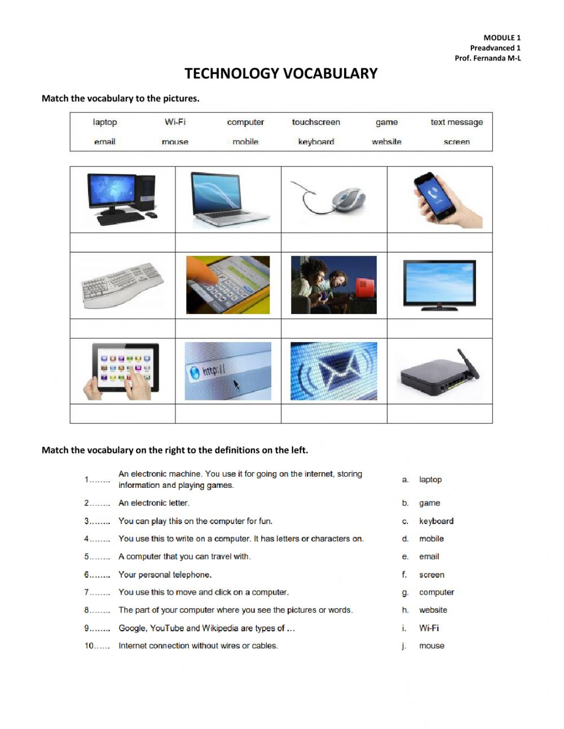
a__________________ b ___________________ c____mouse__________ d________________
e____________________ f ___________________ g __________________ h___________________
i____________________ j___________________ k __________________ l___________________

- Read and answer part A, B and C.

Technology
and your Health

I have believed for a while that mobiles, mobile phone masts and another technology is harmful to our health, due to the exposure of radiation. Scientists at the very least think mobile phones should be used as little as possible. They think it is better to be cautious about using mobiles and a lot of scientists believe they are harmful to your health. Mobile phones are particularly bad for children. The phone companies will tell you that they are safe. But remember they are selling a product so they are hardly going to put you off buying their product by telling you it is unsafe. Where there is a lot of money involved there tends to be corruption. So don't think that they or the government, who get a tax of the money from the use of masts and mobile phones that are put up, have your best interests in mind.
After all people said that smoking, asbestos, a medication called Thalidomide, pesticides and so on were either safe or wouldn't cause you serious harm. However, they were wrong as they caused cancer, disability and terrible illnesses.
I think technology will be to the next generation what drink, smoking and drugs have been to previous generations. In fact, research claims mobile phones could kill more people than smoking.
Wireless (wi-fi) can cause headaches, nausea, tiredness and memory loss in some people. Technology can be particularly hazardous if you are sensitive to it. We have so much technology now there is 24-hour television, computers, Nintendo games, phones and so on. It is not just mobiles but Dect phones (cordless) too and on top of all this there is wireless as well.
Electrical gadgets in the bedroom can also cause sleep problems. It is best to have no electronic items in your bedroom. But if you can't do without them at least make sure you don't have a computer, cordless phone or mobile in your bedroom or at least make sure that are turned off. Cordless phones emit a high amount of radiation this is because they have to be on all the time so that the phone can be charged up. If you didn't do this the phone wouldn't work. So keep your technology use to a limited amount of time each day. Particularly keep your use of mobile phones to a minimum and use a landline instead, because mobile phones can cause cancerous brain tumours if they are used for a long period of time over the years.
Always remember that your health is very important as you might find you are unable to return to good health once you have lost it.
To find out more about protecting yourself from these dangers visit www.wiredchild.org.

http://www.childrenswebmagazine.com/Technology%20and%20your%20Health.html (slightly adapted)
C) Say if the following statements are True (T) or False (F). Correct the false ones.
1. The author of the text is against the use of technology. ( )
------------------------------------------------------------------------------------------------------------
2. We should use mobile phones as much as possible. ( )
------------------------------------------------------------------------------------------------------------
3. Scientists consider mobile phones shouldn’t be used by children. ( )
------------------------------------------------------------------------------------------------------------
4. Scientists and phone companies’ opinion on mobile security diverge. ( )
------------------------------------------------------------------------------------------------------------
5. Research claims smoking kills much more than mobile phone use. ( )
------------------------------------------------------------------------------------------------------------
6. Electrical appliances in the bedroom are advisable. ( )
------------------------------------------------------------------------------------------------------------
Activity 2: Lea detenidamente la información y realice el ejercicio A y B con ayuda del glosario al final del documento.

Phrasal Verbs - Computers and Technology
Los verbos compuestos en inglés, también conocidos como phrasal verbs, son verbos compuestos por dos palabras, un adverbio y una preposición que al ser utilizados juntos adquieren significados diferentes. Antes de explicar a fondo qué son los verbos compuestos en inglés, entendamos a detalle sus componentes:
- Verbo (Verb)  El verbo es una palabra que describe una acción, algo que está sucediendo, un estado del ser o una acción que se está realizando. Ejemplos:  To eat: Comer  To come: Venir  To sleep: Dormir | - Preposición (Preposition)  Las preposiciones describen una relación entre dos palabras, tratan principalmente de lugares o ubicaciones. Ejemplos:  On: En  Through: Por/ A través de  Around: Alrededor. | - Adverbio (Adverb)  El adverbio describe al verbo. Ejemplos:  Quickly: Rápidamente  Slowly: Lentamente  Gently: Gentilmente

  - Find phrasal verbs in the text “Technology and your Health” and write them with their meaning.
  - Read the following conversation and fill in the gaps with the appropriate phrasal verb. Use the glossary.
hack into hurry up log onto popped up put in log into Click on plug in get into turned on

Customer Service: Computer help desk. How can I help you ?
Customer: I need your help. I can’t __________ the system.
Customer Service: I can help you with that. You need to ____________ your computer and power it up.
Customer: I’ve already done all that.
Customer Service: So you’ve ___________ it ___________ ?
Customer: Yes, it’s on. I need to the __________ network.
Customer Service: You want to __________ the system.
Customer: Yes. but I can’t.
Customer Service: Then I need you user ID, please.
Customer: It’s 46821. Please ___________ because I’ve got a conference call starting in five minutes.
Customer Service: OK, no problem. I just sent you a link.
Customer Service: ____________ the link and then scroll down.
Customer: Ah. A message just _______________.
Customer Service: What does it say?
Customer: ‘Are you a robot?’ It wants me to type two words in a little box.
Customer Service: Oh. Are you a robot?
Customer: No, of course not!
Customer Service: Sometimes robots try to__________ our system.
Customer: I’m a human being!
Customer Service: Then just ___________ the words. Key them in.
Customer: It’s impossible. I can’t read them.
Customer Service: Sorry then. I can’t help you. Source:www.simpleenglishvideos.com/computer-terms-phrasal-verbs

REHEARSAL ACTIVITY
THIRD TERM
En su cuaderno desarrolle el taller, marque su trabajo con nombre y grado, tome las fotos y envíelo a susanarivero@iehoracio.edu.co o preséntelo en clase.
SECOND CONDITIONAL

A. ACTIVITIY 1. choose the correct answer.

1. She _________ all over the world if she __________ rich.
- would travel / would be
- travelled / would be
- would travel / were
- travels / were be
2. If I _________his number, I _________ him.
- had / would call
- would have / called
- would had / would call
- have / called
3. If I _________you, I _________ that man.
- were / helped
- weren't / don't help
- am / will help
- were / would help
4. If we _________ a yacht, we _________ the seven seas.
- had / would sail
- have / would sailed
- would have / sailed
- had / sailed
5. If he _________ more time, he _________ karate.
- will have / learns
- had / would learn
- has / would learn
- was have / would learn

B-Activity 2: Read the text and then circle the negative fact or DISADVANTAGES about living in a big city. Then underline the positive or ADVANTAGES ones.

Have You Ever Lived in a Big City?

It is said that living in big cities is expensive because of the high living cost. There are also pollution and traffic problems that make living in big cities unpleasant. However, many people enjoy living in big cities because they offer convenience and countless options for entertainment.

Many big cities already have good public transportation systems, which make it easy for the citizens to go anywhere around the city. This also reduces and helps overcome the problem of traffic jams that often occur at peak times. With the convenience of public transportation, the citizens do not have to drive everywhere and can save money as they do not have to pay for parking charges.

Staying healthy is everybody’s concern and in big cities you can find the best possible medical care for any diseases, especially the severe ones. Moreover, compared to rural areas, access to medical treatment is easier because there are always clinics or medical centers that open 24 hours in many parts of the city so you can get medical help anytime, as soon as you need it. Reaching hospitals is also easier as public transport is usually available 24 hours a day.

There is a saying that big cities never sleep. This is true for some cities in which the nightlife begins just when people in other cities are ready to go to bed. Big cities like New York, Madrid, London and Paris have vibrant nightlife. People can still find entertainment, dine out or go shopping into the early hours.

City dwellers are usually more diverse and there are many communities that hold social events or parties, which provide interesting opportunities for social interactions and social networking. The social interactions allow you to learn about other cultures and share interests with people from different backgrounds, which makes you more open minded and able to understand individuals. On the other hand, the social networking helps you to broaden not only personal but also professional relationships.

All in all, living in big cities is more convenient because of the complete facilities provided. The advanced transportation system enables the citizens to access public facilities easier, cheaper and faster. Big cities also provide better education and health service. In addition, city life is more fun and exciting because there is a wide range of entertainment to enjoy and a lot of social events to attend.

B-Choose the right answer.

1) Why do many people like living in big cities?
A) It is more expensive.
B) It is more modern.
C) It is more crowded.
D) It offers more entertainment.
2) What is the advantage of a good public transportation system?
A) People do not need to buy bus tickets.
B) People do not need to drive their car everywhere.
C) People can use public transport for free.
D) People have to pay for parking charges.
3) Why is it easier to get medical treatment in big cities?
A) Because medical treatment is more affordable.
B) Because hospital facilities are more complete.
C) Because ambulances are provided for free.
D) Because medical centers open 24 hours.
4) What can people in big cities do in the early hours but people in rural areas cannot?
A) Dine out
B) Sleep
C) Go jogging
D) Travel
5) What is the benefit of attending social events?
A) You can treat your friends.
B) You can be a social person.
C) You can learn about cultural diversity.
D) You can be more open about yourself.

Read and answer the questions in the answer sheet
What have you done?
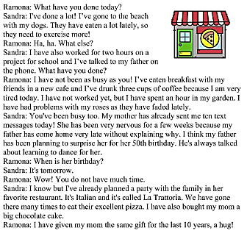

- Sandra has gone to the beach with her dogs.
a. true b. false

- Sandra needs more exercise.
- true b. false

- Sandra`s father has texted her three times today.
- true b. false

- Ramona has eaten breakfast with Friends.
- true b. false

5. Both girls are very busy
a. true b. false
6. Sandra´s mother is celebrating her birthday today.
a. true b. false
7. Sandra has not forgotten mother´s birthday.
a. true b. false
8. Ramona always organizes a party for mother.
a. true b. false
Grammar.
Active and passive voice.
- I_______ by somebody.
- Hit b. was hit

- We ____ the bus
  - Stopped b. were stopped

- My car _______ by a thief.
  - Stole b. was stolen

- They _______the lottery.
  - Won b. were won

- Their beds_______by them
  - Made b. were made

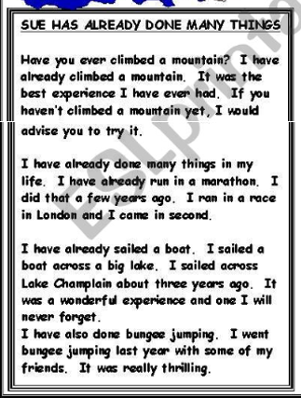

- What is the best experience that Sue has ever had?
a.Sailing b. climbing c. running d. bungee jumping
- What activity did Sue do in London?
a.Sailing b. climbing c. running d. bungee jumping
- How long has Sue sailed a boat?
a. One month ago b. three weeks ago c. three years ago.
- How did Sue felt sailing?
a.Sad b. happy c. wonderful d. thrilling
- Sue has done bungee jumping:
a.Alone b. with his girlfriend c. with his family d. with friends
19. The activity of bungee jumping was:
a.Sad b. happy c. wonderful d. thrilling
- What was the activity that is unforgettable for Sue?

a.Sailing b. climbing c. running d. bungee jumping

