 | INSTITUCIÓN EDUCATIVA HORACIO MUÑOZ SUESCUN  TÉCNICO COMERCIAL  Resolución de Aprobación 16314 del 27 de Noviembre de 2002  DANE: 105001011606 NIT: 811.019.157-3  “Educamos comercialmente para servir” | GDA: 08  V: 01  9/05/2013
 | GUIA DE APRENDIZAJE PERIODO I II III IV V | GDA: 08  V: 01  9/05/2013

Espacio para llenar por el estudiante.
NOMBRES Y APELLIDOS DEL ESTUDIANTE
GRADO: GRUPO:
NOMBRES Y APELLIDOS DEL DOCENTE: SUSANA RIVERO SILVA susanarivero@iehoracio.edu.co
ÁREA Y/O ASIGNATURA: INGLES

PROMOCION ANTICIPADA
Vea los siguients videos:
https://www.youtube.com/watch?v=wLuNOWXw96c
https://www.youtube.com/watch?v=-PjxWSLGXo8
https://www.youtube.com/watch?v=6ATj9Do_RL8
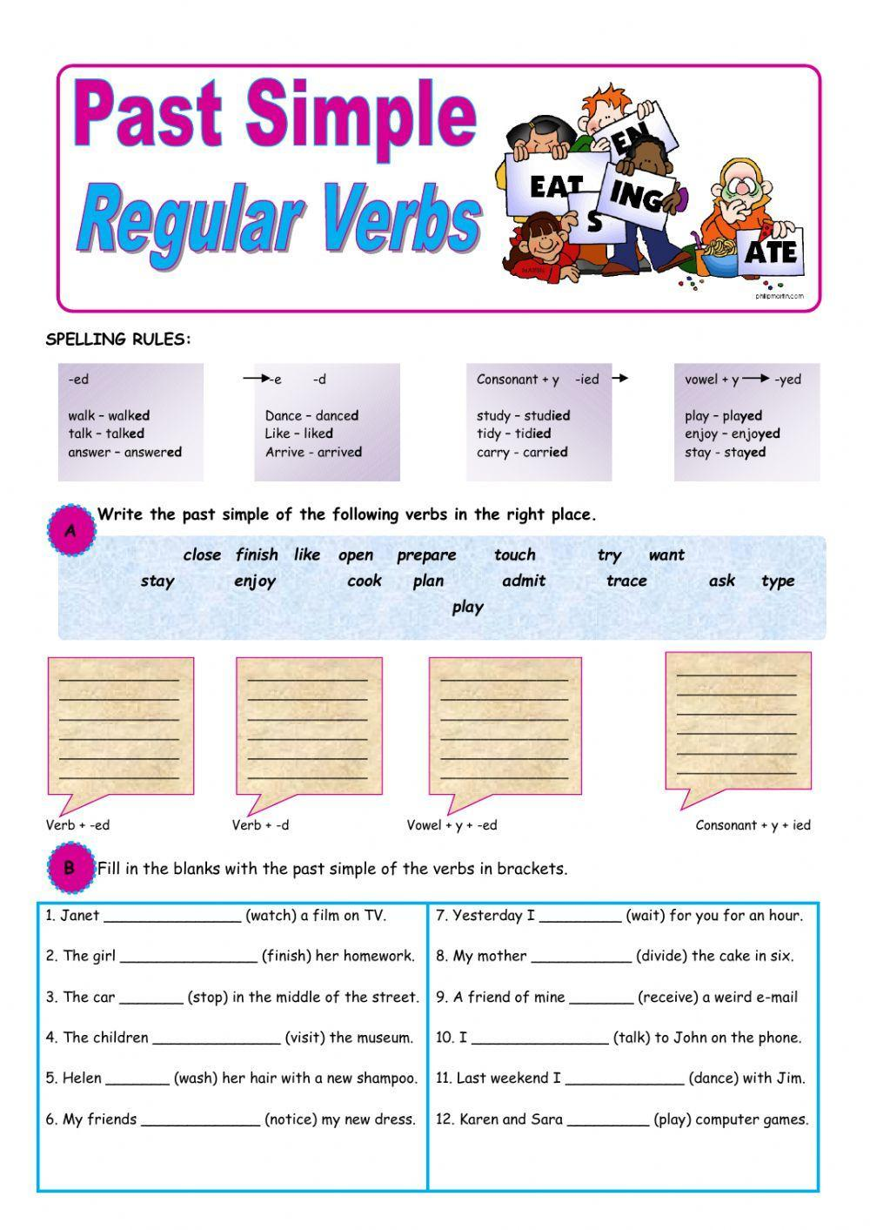
PAST SIMPLE

 | INSTITUCIÓN EDUCATIVA HORACIO MUÑOZ SUESCUN  TÉCNICO COMERCIAL  Resolución de Aprobación 16314 del 27 de Noviembre de 2002  DANE: 105001011606 NIT: 811.019.157-3  “Educamos comercialmente para servir” | GDA: 08  V: 01  9/05/2013
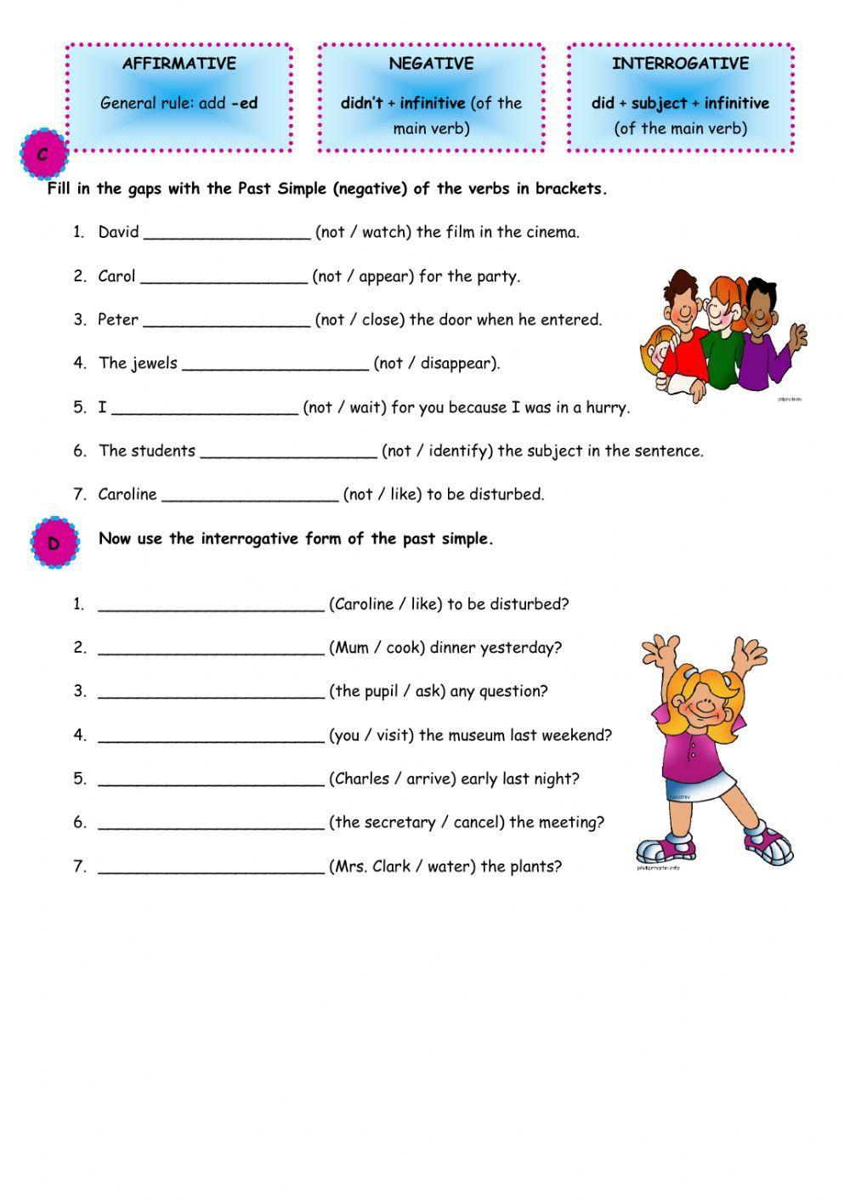
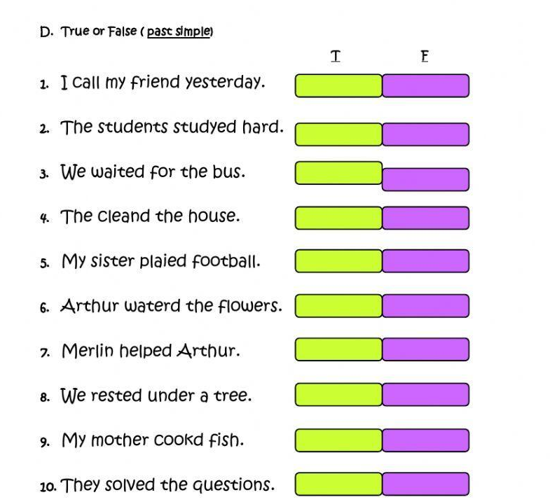
IRREGULAR VERB

E. PUT THE VERBS IN THE PAST SIMPLE
1. Be----------- ----------
2. Buy----------------------
3. Catch-----------------------
4. Choose----------------------
5. Do---------------------------
6. Drink-------------------------
7. Drive--------------------------
8. Eat--------------------------
9. Find--------------------------
10. Forget------------------------
11. Get--------------------------
12. Give--------------------------
13. Go----------------------------
14. Hear--------------------------
15. Know-------------------------
16. Make-----------------------
17. Meet-------------------------
18. Put--------------------------
19. Read-----------------------
20. Ride------------------------
21. Run--------------------------
22. Say-----------------------
23. See--------------------------
24. Sleep--------------------------
25. Speak-------------------------
26. Take ------------------------
27. Think ------------------------
28. Write-------------------------
F.IN THE LIST OF IRREGULAR VERBS 4BE” IS A LITTLE SPECIAL BECAUSE IT DOESN’T NEED 4DID” TO MAKE QUESTIONS OR NEGATIVE SENTENCES.
Put “Be” in the correct form of the past in the following sentences.

    - I very tired yesterday night.
    - They at the cinema.
    - She angry with her pupils.
    - My mum at hospital last week;
    - The shops open last Sunday.
    - You -------------at home yesterday, where---
you?
    - all your friends at your birthday
party?
    - My sister well last Saturday, so
she stayed at home and didn’t come with us.
    - The girls at the mall to do some
shopping.
    - He afraid to miss his bus, so he -
---------in a hurry yesterday after school.

G. COMPETE THE TABLE WITH THE PAST OF THE VERB: SWIM”
I --------------------------
You-------------------------
She--------------------------
He--------------------------
It----------------------------
We--------------------------
You--------------------------
They------------------------

What can you deduce from this?
H. COMPLETE THE SENTENCES WITH THE VERBS IN BRACKETS IN THE PAST SIMPLE;
  - They (take) the train to go to London.
  - She (ride) her bike under the rain.
  - They (make) pancakes for Shrove
Tuesday.
  - She (come) alone at the party.
  - I (buy) a new laptop last week.
  - We (forget) the meeting last
Monday.
  - They (go) to Madrid last year.
  - We (drive) all the way to Paris.
  - My sister (cut) herself doing DIY jobs.
  - They (sleep) well all night.

- IN THE LIST OF IRREGULAR VERBS 4BE” IS A LITTLE SPECIAL BECAUSE IT DOESN’T NEED DID” TO MAKE QUESTIONS OR NEGATIVE SENTENCES.
Put “Be” in the correct form of
the past in the following sentences.

    - I very tired yesterday night.
    - They at the cinema.
    - She angry with her pupils.
    - My mum at hospital last week;
    - The shops open last Sunday.
    - You -------------at home yesterday, where---you?all your friends at your birthday party?
    - My sister well last Saturday, so she stayed at home and didn’t come with us.
    - The girls at the mall to do some shopping.
    - He afraid to miss his bus, so he ----------in a hurry yesterday after school.
    - Why you in the Head’s office this morning?

  - BWRITE THE SENTENCES ABOVE IN NEGATIVE AND INTERROGATIVE.

K. Put each word in the appropriate box
Double – decker bus – check in – book a holiday – Taxi – plane – check out – metro – brochure – hotel – saharian tourism – tours – double room – coach – green tourism – single room – travel agency – sightseeing – underground- tourist guide – train
Transport | Tourism
A Postcard from Greece

L. The following postcard letter describes Helen’s holiday in a foreign country. Read the text and complete the exercises below.
Dear James,  This vacation is wonderful. I arrived by ship to the island.  The island is beautiful and the weather is hot and sunny every day.  I arrived on Saturday morning and I went to Agios Sostis beach.  I took a long swim and then I sunbathed until noon. Next, I had lunch at a tavern on the beach. Also, I met some boys from Romania and we played volleyball with some of the local people. They are all very friendly.  In addition, I loved the hotel because it is fantastic, very modern, and it also has a pool. I liked the town , I walked around and took some photos. Then, I went to Delos to visit the ancient ruins.  Finally, I went shopping yesterday and I bought you a nice present.  I hope you like it. See you when I get home.  Love,  Helen  Love | Mr. James Hook  1128 West Fourth Avenue  New York, NY 10003  USA

* Read the text and select the most appropriate answer. * Mark with an X True or False for the next statements

- Helen did not visit the ancient ruins of Delos | TRUE | FALSE
- She bought a present for her cousin. | TRUE | FALSE
- Helen played volleyball with foreigners. | TRUE | FALSE
- She said that the people from the island weren’t friendly | TRUE | FALSE
- The island’s weather is warm and sunny every day. | TRUE | FALSE
- Where is Helen on vacation?
- In Turkey.
- At a beach.
- In Greece.

- When did she arrive?
- She arrived on Saturday.
- She got there by ship.
- She arrived last weekend.

- Where did she go first?
- She first stayed at the town’s hotel.
- She went to Agios Sostis beach.
- She went to have lunch at a beach’s tavern.

- Who did she meet on Sunday?
- She met old friends.
- She did not meet anyone.
- She met some Romanian boys.

- Why does Helen love the hotel?
- Because it is cheap and comfortable.
- Because it features a pool and it is modern.
- Because it doesn’t have many people.

Writing Postcards

Imagine you are on holiday in a foreign country with some friends. Write about what you did there, describe some places that you
visited, what you liked or disliked about the place. Also, give a brief description of the city. Use linking words such as :
First, second, but, and, so, because, also, finally.

Words (80 -100)

.
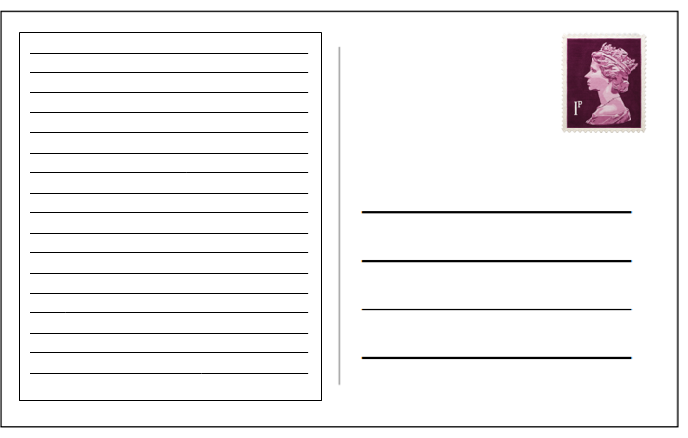
THE PRESENT PERFECT TENCE
A-Complete the sentences using the past participle of the verbs in brackets.
- The train has ___________. We can go out now. (stop)
- She isn’t ready. She hasn’t __________ her cases yet. (pack)
- She has ___________ some photos. (take)
- Sally hasn’t ___________ yet. Where can she be? (arrive)
- I’ve never ____________ to your mother. (speak)
- I haven’t ____________ which shoes to buy yet. (decide)
- My father has ___________ to Rome. (drive)

B-Choose the correct verb from the box and complete the sentences using the present perfect form.
- Tom _________________ the rubbish.
- Claire ________________ all the questions.
- I ___________________ ten kilometres.
- They ________________ their car keys.
- John ________________ a new jacket.
- Diana ________________ her arm.
- Bill and Tim _________________ the kitchen.
- The train __________________ the station.
- Karen _____________________ her violin practice.
answer break buy clean empty leave lose finish walk

C-Complete the sentences. Use the present perfect – positive or negative.
My mum isn’t at home now. She ___________ (go) to the supermarket.
So far this month I ______________ (see) three films.
I’m hungry. I _____________ (have) my lunch yet.
I _________________ (see) Helen yet today. Is she at school?
Our football team ________________ (win) all its matches so far this year.
I don’t know your boy-friend. I ____________ (meet) him yet.

D-Complete what Susan says. Use the PPT and for or since.
a) I’m from France, but I live in London now.
I ____________ (live) here _________1992.
b) I’m a journalist. I work for a sports magazine in London. I ___________(work) there _________ two years.
c) I’m married. My husband’s name is Jonathan.
We _____________(be) married _________1993.
d) Jonathan works in a bank.
He ___________(work) there _________ three years.
e) We have a flat in south London.
We ________ (have) the flat ________ last May.

NOTA: Entregue el taller cuando llegue a clases y prepárese para el EXAMEN sobre el trabajo. El trabajo vale un 40% y el examen un 60%.

Put the words in the right order.
a) I/homework/yet/finished/ haven’t/my
______________________________
b) I/homework/my/done/have/already
______________________________
c) I/homework/my/finished/have/just
______________________________
d) He/home/gone/has/already
______________________________
e) Mark/come back/France/just/has/from
______________________________
f) They/bought/new/a/just/have/house
______________________________
g) We/had/lunch/haven’t/yet
______________________________
h) The train/the station/already/left/has
______________________________
i) left/the train/yet/has/?
______________________________

