Name: _____________________________________________________________

Group: _____________________________________________________________

Date: _________________

PREGUNTAS DE SELECCIÓN MÚLTIPLES CON ÚNICA RESPUESTA cada pregunta tiene un valor de 0.25%

PART I- ADVICE INTERPRETATIONS

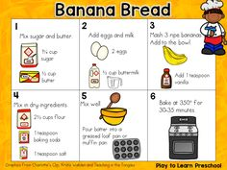
- According with step 2 how many eggs we must use to cook banana bread:
- We will need many eggs
- We will need an egg
- We will need 2 eggs
- We don’t need any eggs
- According with step 3 how many bananas we must use to cook banana bread:
- We will need many bananas
- We will need a banana
- We will need 2 bananas
- We don’t need any bananas
- According with step 1 how much butter bar we must use to cook banana bread:
- We will need much butter
- We will need a butter bar
- We will need 2 butter bars
- We don’t need any butter bar

PART II – CHOOSE THE BEST WORD TO COMPLETE THE TEXT, YOU HAVE MORE OPTIONS THAN YOU NEED.
CLASSIC CHICKEN SOUP
INGREDIENTS
1 3½- to 4- (4)______chicken
6 carrots, peeled
4 celery stalks
1 large yellow onion, quartered
2½ (5)___________ of salt
1 teaspoon whole black peppercorns
4 (6) _____ of water
- Gallon
- Pound
- Cups
- Teaspoons
- Pint

PART III – CHOOSE THE BEST PHRASE TO COMPLETE THE DIALOGUE.
7. Part one
Student 1 Do you want to go out to eat tonight?
Student 2 No, I am going to cook dinner at my house. Would you like to come over to eat?
Student 1 Yes, thank you for inviting me. What are you going __________________?
- To cook for dinner
- To bake for dinner
- To eat for dinner
- To wash for dinner

8. Part two
Student 2 I am going ____________________
Student 1 That sounds good. How are you going to cook everything?
Student 2 I am going to boil the rice, barbeque the chicken, and bake the bread.
- To make soup, rice and meat
- To make chicken, rice, salad, and bread.
- To make salad and pasta
- To make hamburguer and french fries

9. Part three
Student 1 What kind of salad are you going to make?
Student 2 I am going ___________________

Student 1 Everything sounds great. Ummm yummy potato salad Do you need any help making dinner or do you want me to bring something?
Student 2 No, just come to my house at 6:00 pm.
Student 1 Okay, I'll see you tonight.
- to make potato salad.
- to make celery salad.
- to make carrot salad.
- to make cherry salad.

PART IV – Classify the words
- Countables
- Carrots
- Rice
- Soup
- Milk
- Uncountables
- Watermelons
- Carrots
- Water
- Butter bar
- Countables
- Cup of milk
- Milk
- Water
- Juice

PART V – Reading Comprehension
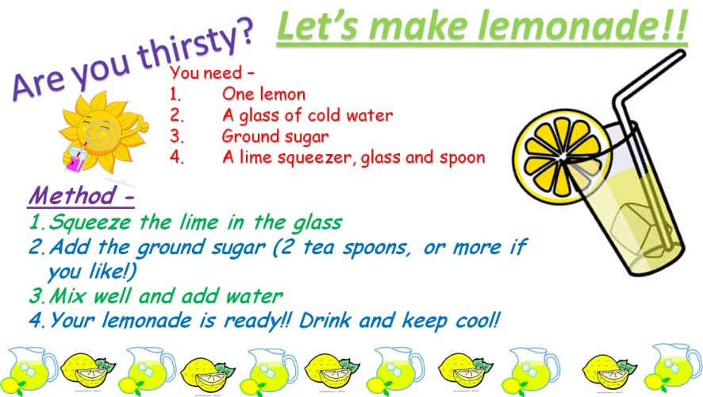
- What kind of ingredients do you need to make a limonade?
- Lemon, Ice, Milk, and Salt
- Lemon, chicken, water and salt
- Lemon, milk and sugar
- Lemon, cold water,ground sugar,lime squeezer,glass and spoon
- What is the first step to make a limonade?
- Your limonade is already drink and keep cool
- Add the ground sugar ( 2 teaspoon or more if you like)
- Squeeze the lime in the glass
- Mix well and add water
- What is the second step to make a limonade?
- Your limonade is already drink and keep cool
- Add the ground sugar ( 2 teaspoon or more if you like)
- Squeeze the lime in the glass
- Mix well and add water
- What is the final step to make a limonade?
- Your limonade is already drink and keep cool
- Add the ground sugar ( 2 teaspoon or more if you like)
- Squeeze the lime in the glass
- Mix well and add water

PART VI – Reading Comprehension long texts

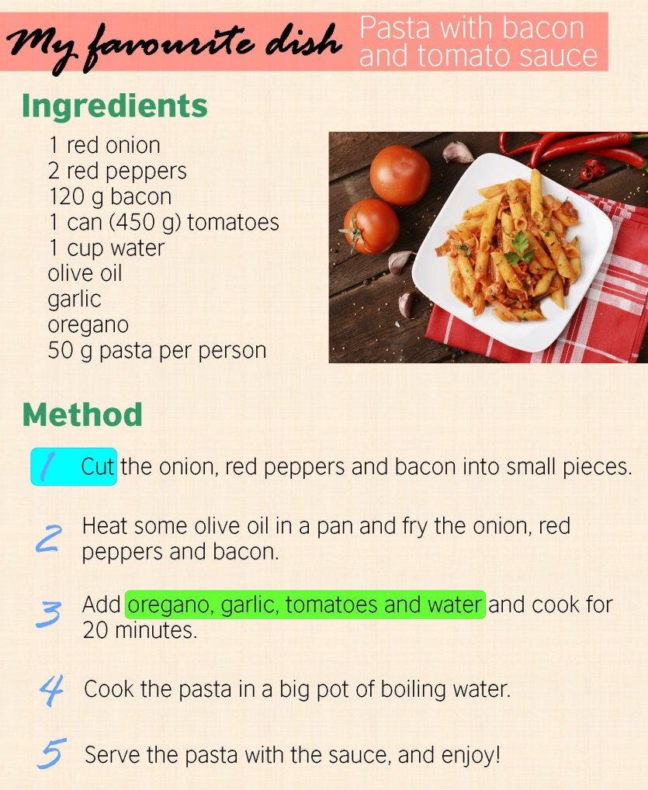
How many red peppers do you need?
- 2 red peppers
- 4 red peppers
- 6 red peppers
- 8 red peppers

Cut is similar to
- Put
- Add
- Bake
- Slice

The expression “some olive oil” means that:
- Olive is a countable noun
- Olive is an uncountable noun

Where do you cook the pasta
- In a big pot
- In a big bowl
- In a big cup
- In a dish

What ingredients do you need to add?
- Onions, tomato and bacon
- Oregano, tomatos, garlic and water
- Sugar, Vanilla and Ice
- Pepper, carrots and onions

